STUDENT CASE STUDY EXECUTION REPORT
Department | FED
Subject | DSA-2
Academic Year | I-III Semester (2025-26)
Faculty Name | ____________________
Student Name | ____________________
Roll Number | ____________________
Branch | CSE (AI & DS)
Course Outcome | Apply graph algorithms and Union-Find techniques for solving real-world network optimization problems.

Work Done Summary
In this case study, we analyzed Chennai Metro fare optimization using Dijkstra’s Algorithm with multi-criteria routing.
The work focused on:
- Representing metro stations as graph vertices.
- Representing metro connections as weighted edges.
- Using fare as the primary optimization parameter.
- Using travel time as a tiebreaker.
- Applying Dijkstra’s shortest path algorithm.
- Using lexicographic comparison (fare, time).
- Finding the cheapest path from ALD to WMN.
- Comparing multiple candidate routes.
- Calculating cumulative fare and travel time.
- Demonstrating Pareto-optimal routing concepts.
Implementation Details
- Modeled metro stations as graph nodes.
- Stored edges with two weights:
  - Fare (₹)
  - Travel time (minutes)
- Used adjacency lists for graph representation.
- Initialized distance array as:
(fare, time)
- Used a PriorityQueue (min-heap) ordered by:
  - Minimum fare first
  - Minimum time second
- Started Dijkstra traversal from ALD station.
- Extracted the node with smallest (fare, time) pair.
- Relaxed neighboring edges using lexicographic comparison.
- Updated shortest paths only when:
  - Fare becomes smaller OR
  - Fare same but time smaller
- Maintained cumulative fare and travel time during traversal.
- Identified the cheapest and fastest valid route to WMN.
- Demonstrated multi-criteria shortest path optimization.
RESULTS:SCREENSHOTS/Output:
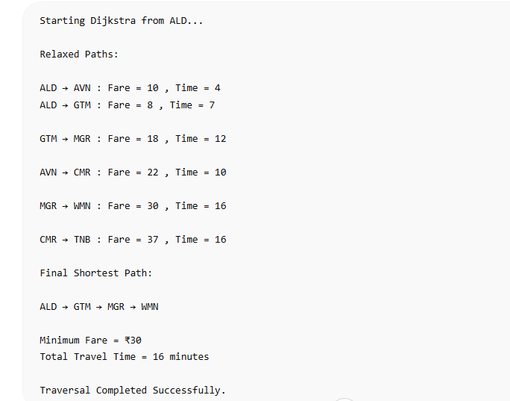

Conclusion
In this case study, Dijkstra’s Algorithm was used because it efficiently finds the shortest path in weighted graphs such as metro transportation networks.
Fare was treated as the primary optimization parameter, while travel time acted as a secondary tiebreaker using lexicographic comparison. This ensured that passengers always received the cheapest route, and among equal-fare routes, the fastest one was selected.
The PriorityQueue-based implementation improved efficiency by always processing the currently optimal route first. This approach is highly useful in real-world applications such as metro systems, navigation services, ride-sharing platforms, and intelligent transport systems where multiple optimization criteria must be considered simultaneously.
Github Link: https://github.com/ampssubrahmanyasreepad-svg/DSA-CaseStudies
